BASED ON: THE HAPPIEST BABY ON THE BLOCK
All babies cry—and that’s a good thing. How else would we know if our helpless infants were cold, hungry, lonely or in pain? Being outside of the womb is a scary experience! The rhythms experienced inside the womb trigger a reflex that keeps babies relaxed. This calming reflex is a virtual off-switch for crying and on-switch for soothing. Parents have long turned to similar womb-mimicking tricks, like going for car rides and turning on the vacuum cleaner to soothe their babies. The calming reflex is triggered by The 5 S’s: Swaddle, Side-Stomach Position, Shush, Swing and Suck.
The 1st S: Swaddle
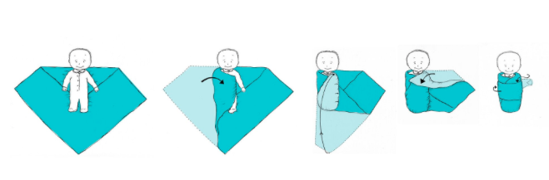
Swaddling recreates the snug packaging inside the womb and is the cornerstone of calming. It decreases startling and increases sleep. And, wrapped babies respond faster to the other 4 S’s and stay soothed longer because their arms can’t wriggle around. To swaddle correctly, wrap arms snug—straight at the side—but let the hips be loose and flexed. At first, your baby may be upset with swaddling, it may be difficult. After 5-10 times it will be as easy as changing a diaper. Have your doula show you!

The 2nd S: Side or Stomach Position
The back is the only safe position for sleeping, but it’s the worst position for calming fussiness. This S can be activated by holding a baby on her side, on her stomach or over your shoulder.
The 3rd S: Shush
Babies do not need silence! In the womb, the sound of the blood flow is a shush louder than a vacuum cleaner! The best way to imitate these magic sounds is white noise.
The 4th S: Swing
While slow rocking is fine for keeping quiet babies calm, you need to use fast, tiny motions to soothe a crying infant mid-cry. Dr. Karp calls this movement the “Jell-O head jiggle.” To do it, always support the head/neck, keep your motions small; and move no more than 1 inch back and forth. Imagine trying to imitate a strong vibration. (Never shake your baby in frustration.)
The 5th S: Suck
Sucking is “the icing on the cake” of calming. Many fussy babies relax into a deep tranquility when they suck. Many babies calm easier with a pacifier.

